DEVELOPMENT OF THE MODEL FOR AUTOMATIC CAPTURE OF WEATHER INFORMATION BASED ON IOT AND CLOUD TECHONOLGIES

BY
Your full names here (e.g. JACKSON PHIRI)
Student ID

A PROJECT REPORT SUBMITTED IN PARTIAL FULFUILMENT OF THE REQUIREMENT OF A BACHELOR OF COMPUTER SCIENCE DEGREE

THE UNIVERSITYOF ZAMBIA

October 2026

COPYRIGHT
All rights reserved. No part of this material may be reproduced, stored in any retrieval system, or transmitted in any form by any means. Except in case of brief quotations embodied in critical reviews and other non- commercial uses permitted by copyright law of the author, Your Name here or the University of Zambia in that regard.

DECLARATION
I, Your Name Here do hereby declare that this report is my own original work and has not been submitted to any other college, institution or university other than the University of Zambia.

Name: …………………………………………………………………………….
Sign: ………………………………………………………………………………
Date: ………………………………………………………………………………

APPROVAL
This report, by Your Name Here has been approved as partial fulfilment of the requirements for the award of Master of Business Administration (Management Strategy by the University of Zambia.

Student
Name: ………………………………………………….
Signature: …………………………………………………..
Date: …………………………………………………..

Supervisor
Name: ………………………………………………….
Signature: …………………………………………………..
Date: …………………………………………………..

ACKNOWLEDGEMENTS
This research would not have been possible without considerable information and facts gotten from other researchers and sources that have researched extensively on communication and to this the researcher duly acknowledges their input to the study.
My deepest appreciation goes to my supervisor, Prof. Jackson Phiri for taking the patience of reading through my work and making constructive criticisms and useful suggestions that helped me to stay focused from the beginning of this work till the end. I am highly indebted to my parents, for their constant financial, material and moral support without which this research would not have been made possible; and to all my brothers, sisters and family for their love, encouragement and prayers which gave me the strength to go on at every stage.
Secondly, I wish to extend a heartfelt thank you to all my incredibly special friends whose discussions and ideas in one way or another enlightened me while carrying out this research. Finally, I would like to say special thanks to God Almighty for giving me his grace throughout this period and providing me with both the intellectual and physical capacities and the opportunity to live up to the completion of this research. To all those whose names have not been mentioned here, know that am grateful to you.

DEDICATION
To my parents, Mr xxxxxxxxxx and Mrs xxxxxxxxxx, for their financial support throughout this sxxxxxxxxxxxxxxxxxxxxxxxxxxxx dddddddddddddddddddddddddddddd fffffff ffffffffffffffffffff gggggggggggggggggggggggg hhhhhh

ABSTRACT
Communication is a very crucial and significant element in an organization, and it is necessary for creating collaboration within the work environment that have effects on organizational performance and decision making. This study on effects of effective communications on organizational performance using the systems theory is thus essential. The objectives of this study were to firstly identify the factors affecting effective communication based on the systems theory and secondly to devise a communication model that addresses these factors to improve organisational performance. A quantitative approach was used to describe and analyse data collected for the study from 88 respondents. A questionnaire was used to identify factors affecting effective communication based on systems theory. Descriptive analysis and Pearson’s correlation were used to analyse the results. The results for H₁ showed a Pearson correlation coefficient of 0.642 which is statistically insignificant if the (sig. 2-tailed) < 0.05 indicating that there was no statistical significant relationship between management and channel of communication used. However, the results from H₂ indicated that there was a relationship between Channel of communication used and effective communication with a Pearson correlation coefficient of 0.041 at (sig. 2-tailed) < 0.05 between communication channel variable; channel normally used and effective communication variable; receives information from preferred sources. Lastly the correlation results from H₃ showed that effective communication has a positive effect on organizational performance at (sig. 2-tailed) < 0.05 indicating a Pearson’s correlation coefficient of 0.012.
Keywords: Effective, Communication, Performance, Systems theory, Organisation

TABLE OF CONTENTS
COPYRIGHT i
DECLARATION ii
APPROVAL iii
ACKNOWLEDGEMENTS iv
DEDICATION v
ABSTRACT vi
TABLE OF CONTENTS vii
LIST OF TABLES x
LIST OF FIGURES xi
LIST OF ABBREVIATIONS xii
1 INTRODUCTION AND BACKGROUND 1
1.1 Introduction 1
1.2 Background 1
1.3 Statement of the Problem 1
1.4 Aim of the Study 1
1.5 Research Objectives 1
1.6 Research Questions 1
1.7 Significance of the Study 2
1.8 Scope of the study 2
1.9 Organization of the Report 2
1.10 Chapter Summary 2
2 LITERATURE REVIEW 3
2.1 Introduction 3
2.2 Background to the Study 3
2.2.1 Sub Thematic Area 1 3
2.2.2 Sub Thematic Area 2 3
2.2.3 Sub Thematic Area 3 3
2.3 Thematic Area 1 related to objective 1 3
2.3.1 Sub Thematic area 1 3
2.3.2 Sub Thematic area 2 3
2.3.3 Sub Thematic area n 3
2.4 Thematic Area 2 related to objective 2 4
2.4.1 Sub Thematic area 1 4
2.4.2 Sub Thematic area 2 4
2.4.3 Sub Thematic area n 4
2.5 Thematic Area n related to objective n 4
2.5.1 Sub Thematic area 1 4
2.5.2 Sub Thematic area 2 4
2.5.3 Sub Thematic area n 4
2.6 Related Works and Gaps in the Literature 5
2.7 A Summary of the Related Works 5
2.8 Chapter Summary 6
3 RESEARCH METHODOLOGY 7
3.1 Introduction 7
3.2 Research Design 7
3.3 Baseline Study (Optional Section for Computer Science Project) 7
3.3.1 Population of the Study 7
3.3.2 Sample Size and Sampling Technique 7
3.3.3 Data Collection Methods 7
3.3.4 Instruments for Data Collection 7
3.3.5 Questionnaire 7
3.3.6 Data Analysis 8
3.4 System Design and Implementation (Required Section for Computer Science Project, about 15 pages) 8
3.4.1 Proposed Business Process 8
3.4.2 Requirements Specification 8
3.4.3 Design Specification 8
3.5 System Implementation (Required Section for Computer Science Project) 8
3.5.1 System Development 8
3.5.2 System Deployment 8
3.6 Chapter Summary 8
4 RESULTS 9
4.1 Introduction 9
4.2 Baseline Study Results (Optional Section for Computer Science Project) 9
4.3 9
4.3.1 Descriptive Statistics 9
4.3.2 Hypothesis Testing (Inference Statistics) / Thematic Analysis 9
4.4 System Automation and Implementation Results (Required Section for Computer Science Project) 10
4.4.1 System Implementation Results 10
4.4.2 System Validation 10
4.5 Chapter Summary 10
5 DISCUSSION AND CONCLUSIONS 11
5.1 Introduction 11
5.2 Discussion 11
5.2.1 Objective 1 Discussion 11
5.2.2 Objective 2 Discussion 11
5.3 Conclusions 11
5.4 Recommendations 11
5.5 Future Works 11
5.6 Chapter Summary 11
REFERENCES 12
APPENDICES 13
Appendix 1 - Questionnaire 13

LIST OF TABLES
Table 1: Literature Review and Gaps (Give A Minimum of 10 Key Articles) 5
Table 2. Inventory Functional Requirement Table 9
Table 3. Media Functional Requirements Table 9
Table 4. Non-Functional Requirements Table 10
Table 5. Hardware Requirements Table 10
Table 6. Software Requirements Table 12

LIST OF FIGURES
Figure 1 .Business Process Model 7
Figure 2 System Overview Diagram 13
Figure 3. Technical Member Use Case Diagram 14
Figure 4. Class Diagram 15
Figure 5. Dashboard 17
Figure 6. Media Center 17
Figure 7. Inventory Dashboard 18

LIST OF ABBREVIATIONS

INTRODUCTION AND BACKGROUND

Introduction
This chapter provides a brief background to the problem which provides some historical information relating to the research. The problem statement follows the background to put the problem into perspective. The aim of the study is highlighted to identify the main goal of this research and the objectives were used to answer the research questions. The significance of the study is given to define the beneficiaries of the study and finally a summary will be given to after all discussions relating to this chapter.

Background
Accurate, real-time meteorological data is a foundational resource for agricultural planning, disaster warning, urban management, and climate research. The World Meteorological Organization (WMO) notes that the core definition of an Automatic Weather Station (AWS) lies in "instruments that automatically perform observations and transmit or record data without human intervention" [1]. However, the construction and maintenance costs of traditional large-scale meteorological monitoring networks are high, and their coverage scale makes it difficult to capture the spatiotemporal variation characteristics of local microclimates, with deployment particularly constrained in remote areas or regions with weak infrastructure. The maturation of Internet of Things (IoT) technology offers a feasible path to address this dilemma: the combination of low-cost microcontrollers (such as ESP32 and NodeMCU) and sensor modules makes the automatic collection and wireless transmission of meteorological data economically viable [2], [3]; the proliferation of cloud platforms solves the problems of data storage, remote access, and visualization, and IoT cloud services such as ThingSpeak have been validated by multiple studies as reliable data hosting solutions [4], [5].

Statement of the Problem
In essence, the central problem is that existing low-cost IoT weather monitoring solutions remain at the level of isolated prototypes rather than reliable, reusable models. They suffer from three interrelated deficiencies: (i) insufficient automation and reliability in data collection, with inadequate attention to quality assurance principles established by the WMO [3]; (ii) weak data quality mechanisms, particularly the lack of systematic handling of missing and anomalous values before cloud storage [5]; and (iii) limited architectural generality, as design choices regarding microcontrollers, communication protocols, and cloud platforms are rarely compared or abstracted into a transferable framework [2], [7]. Consequently, there is a need for a model that simultaneously addresses cost, data quality, and scalability, and that can deliver automatic meteorological observations with practical reference value for local areas.

Aim of the Study
To design and develop a model for the automatic capture of weather information based on IoT and cloud technologies, achieving automatic collection, reliable transmission, and cloud-based visualization of key meteorological parameters.

Project Objectives

- To design and implement an automatic meteorological data collection node based on microcontroller and multi-sensor fusion.
- To construct a cloud platform-based meteorological data transmission, storage, and visualization channel.
- To establish a data quality assurance mechanism and verify the effectiveness and limitations of the model. Significance of the Study

Importance of the study
Give reasons why the study is important

Scope of the study

This study will be a comparative study of private organizations based in Lusaka. This study will attempt to tackle communication and contemporary research.

Organization of the Report
The report is divided into five chapters as follows.
Chapter One covers the introduction to the report and information on the background of the study. The statement of the problem is given, followed by the aim and objectives. The research questions, scope and significance of the study are also covered in this chapter. Chapter Two outlines the various literature done by different scholars on the subject matter, identifying findings and gaps. Chapter Three highlights the methodology that was employed to carry out the study, discussing the design, population, data collection methods, techniques, and analysis. The proposed research method, hypothesis and ethical considerations are also covered. Chapter Four presents the analysis of the collected data. The chapter also tests and presents the results of the hypothesis stated in Chapter three. It will interpret, discuss, and conclude the results the research results. Chapter Five answers the study questions discussed in the first chapter. Conclusions and recommendations are given based on the findings of the study.

Chapter Summary
This chapter has given a background and problem statement regarding effective communication and organizational performance. The aim of the study was highlighted followed the objectives were used to answer the research questions and lastly the significance of the study was given to define the beneficiaries of the study.

LITERATURE REVIEW (Must have a minimum of 50 peer reviewed references using IEEE format. 15 pages or more)

Introduction
Understanding the effects of communication on organizational performance using the systems theory is the major focus of this study and so this chapter explores the literature that has significance to the objectives and research questions outlined in Chapter One. It will explain the systems theory and its relation to communication, give major findings and gaps between related works and give a summary to the chapter.

Background to the Study

Sub Thematic Area 1

Sub Thematic Area 2

Sub Thematic Area 3

Thematic Area 1 related to objective 1
Give the literature background that addresses the Key Thematic areas of objective 1

Sub Thematic area 1
Messages can be blocked by environmental factors, such as the physical setting or the situation where communication takes place. purpose of communicating should be accurate, precise, and understandable.

Sub Thematic area 2
Messages can be blocked by environmental factors, such as the physical setting or the situation where communication takes place. purpose of communicating should be accurate, precise, and understandable.

Sub Thematic area n
Messages can be blocked by environmental factors, such as the physical setting or the situation where communication takes place. purpose of communicating should be accurate, precise, and understandable.

Thematic Area 2 related to objective 2
Give the literature background that addresses the Key Thematic areas of objective 2

Sub Thematic area 1
Messages can be blocked by environmental factors, such as the physical setting or the situation where communication takes place. purpose of communicating should be accurate, precise, and understandable.

Sub Thematic area 2
Messages can be blocked by environmental factors, such as the physical setting or the situation where communication takes place. purpose of communicating should be accurate, precise, and understandable.

Sub Thematic area n
Messages can be blocked by environmental factors, such as the physical setting or the situation where communication takes place. purpose of communicating should be accurate, precise, and understandable.

Thematic Area n related to objective n
Give the literature background that addresses the Key Thematic areas of objective n

Sub Thematic area 1
Messages can be blocked by environmental factors, such as the physical setting or the situation where communication takes place. purpose of communicating should be accurate, precise, and understandable.

Sub Thematic area 2
Messages can be blocked by environmental factors, such as the physical setting or the situation where communication takes place. purpose of communicating should be accurate, precise, and understandable.

Sub Thematic area n
Messages can be blocked by environmental factors, such as the physical setting or the situation where communication takes place. purpose of communicating should be accurate, precise, and understandable.

Related Works and Gaps in the Literature
Ainobushoborozi (2013) conducted a study which examined the impact of effective communication on labour productivity in civil engineering projects at Kampala Central division.

A Summary of the Related Works
The findings revealed that effective communication help to facilitate better understanding among all parties in the construction organization.

Table 1: Literature Review and Gaps (Give A Minimum of 10 Key Articles)
Author | Topic | Findings | Gaps
Ainobushoborozi (2013) | The impact of effective communication on labour productivity in civil engineering projects | Asking for clarity in communication and timely information about changes affecting work are meaningful to labour productivity.  Also, to achieve the targeted productivity level, managers should confirm clarity or understanding of instructions, provide enough training to employees, make sure cooperation at work exists by providing incentives  A good communication plan should be developed for timely information delivery on changes affecting work. | identifying factors affecting effective communication based on systems theory  developing a communication framework that addresses these factors to improve organizational performance.
(Gautama et al 2018) | Effects of Organisational Communication and Culture on Employee Motivation and Its Impact on Employee Performance carried out by | Organizational communication significantly influenced employee motivation in broadcasting companies. Organisational culture has no significant influence on employee motivation in broadcasting companies. Organisational communication significantly Effect of Organisational Communication and Culture.  Culture has no significant influence on employee performance; and Employee motivation significantly influenced employee | This research will develop a communication framework that addresses these factors to improve organizational performance

Chapter Summary
This chapter reviewed the literature by the other scholars and researchers on the subject matter of effective communication and organizational performance. From the discussions, most studies have focused on the importance of effective communication and its barriers, but they have not advised on what framework can be used to enhance effective communication in organizations. This study therefore seeks to fill this research gap.

METHODOLOGY (Should be very detailed, 20 pages or more)

Introduction
This chapter discusses the research methodologies that were employed in the study. The chapter includes the research design, study population, sampling design, data collection techniques and the data analysis techniques. This chapter also includes the proposed research model, the research hypothesis and concludes the ethical considerations.

Research Design
The research questions were answered using the descriptive study design. Quantitative data was collected in the form of a questionnaire. The use of questionnaires helped the study to generalize findings from data collected from the respondents.
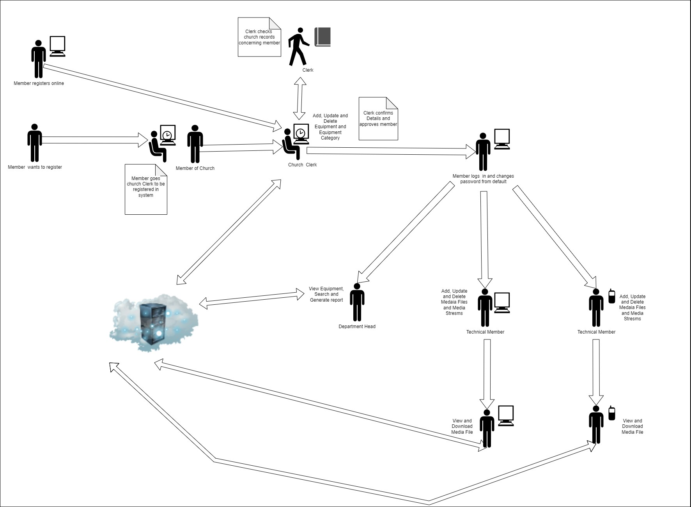
Figure 1 .Business Process Model

On a typical day, most processes in the inventory management system are carried out manually. The management of all church equipment still relies on paper records, and any movement of equipment, whether in or out, is documented using paper records. The developed system aims to digitize the entire inventory management process.

Baseline Study (Optional Section for Computer Science Project)

Population of the Study
Population is the entire aggregation of items from which samples can be drawn for a study (Opoku, 2009). The population targeted for this study consisted of all the staff at three human resource consultancy companies in Lusaka Zambia. Give the details of the population used in your study

Sample Size and Sampling Technique
Give details how you computed the sample size from the study population. Include the formula

Data Collection Methods
This study made use of data obtained from both primary and secondary sources. Primary sources of data

Instruments for Data Collection
The data collection instrument used in this study as a basis for collecting, recording and
measuring data which is required to provide answers to our research questions was a questionnaire.

Questionnaire
Foddy (1995) defines a questionnaire as a carefully written set of questions about a subject that has given to a carefully selected sample of human beings. The questionnaire was designed in two parts: the first part being the identification of respondents, the second part targeted employees who carried out daily tasks.

Data Analysis
After the data collection, the researcher attempted to edit the data collected to ensure consistency of responses. In this regard, statistical tools were used to simplify and make data interpretable and understandable.

System Design and Implementation (Required Section for Computer Science Project, about 15 pages)

Proposed Business Process

Requirements Specification

Functional Requirements

System High Level Overview Design

Functional Requirements

Non-Function Requirements

Hardware Requirements

Software Requirements

Inventory Management System:

Table 2. Inventory Functional Requirement Table
Requirement | Description
Login | Have access into the system using their username and password. Password can be changed by user.
Equipment | Capability to add, delete, and update equipment. Users shall be able to seamlessly add new equipment entries, remove existing ones, and update the details of equipment as needed. QR code shall be generated for each equipment added. Search will be done by name or QR code
Equipment’s category | Ability to manage equipment categories comprehensively. Add new equipment categories, remove existing ones, and update the details of equipment categories as required.

Digital Asset Management (DAMS):
Table 3. Media Functional Requirements Table
Requirements | Description
Media Files | Will be able efficiently organize and categorize of digital assets, providing the capability to seamlessly add, delete, and update media asset records. Has capability to download media assets and conduct efficient searches within the system
Media Stream | Schedule and manage live streaming events

Non-Function Requirements

Table 4. Non-Functional Requirements Table
REQUIREMENTS | DETAILS
Reusability: | The web app is built with Model View Controller (MVC) Design Architecture which promotes reusability of different components.
Maintainability: | The code is clean, well-commented, easy to maintain and update.
Reliability: | Data is accurately stored, retrieved, and updated without errors.
Data Security: | Protect sensitive information, such as member data, through proper authentication and authorization mechanisms through encryption.
Mobile App Security | Protect the mobile unauthorized access, a user can only run one instance of the mobile application and is required to log in on his or her mobile device.
Usability | The web and mobile interfaces are intuitive and easy to use, especially for non-technical users.
Compatibility | The web app is compatible with popular web browsers such as chrome, Microsoft edge, and Firefox etc..  The mobile app is compatible for both iOS and android mobile devises.

Hardware Requirements

Table 5. Hardware Requirements Table
GADGET | SPECIFCATION
Laptop | The hardware requirements for this web application include an Intel Pentium 4 processor or later. However, for macOS, an Intel processor is necessary. In terms of RAM (memory), it is recommended to have a minimum of 2 GB for optimal performance, although the web application can run with less. Additionally, a minimum of 16 GB of free hard drive space available to accommodate the application and its associated data.
Android Phone | It should have a processor (CPU) with a speed of at least 1.4 GHz, and multi-core processors are preferable for smoother performance. A minimum of 2 GB of RAM is recommended for smooth app operation. You'll need adequate free storage space for the app installation and any data it generates, typically ranging from 50MB to several hundred megabytes. The device's screen should have a reasonable resolution and size to ensure the app's user interface displays correctly, a requirement that most modern Android devices meet. Although not mandatory, a capable Graphics Processing Unit (GPU) can enhance the app's performance and visual quality. Additionally, a camera with a resolution of 2 megapixels or higher will to needed to scan the QR code accurately.
Apple Phone | To run a mobile app built with React Native on an iPhone, you'll find that most apps are designed to function across a variety of iPhone models, beginning with the iPhone 5s or later. However, it's important to note that specific app features, such as Face ID, Touch ID, or screen size optimization, can influence device compatibility. Furthermore, it's essential to ensure your iPhone has ample available storage space for the app installation and related data storage, with requirements typically ranging from a few megabytes to several hundred megabytes, depending on the app. In terms of memory (RAM), while React Native apps tend to be memory-efficient, it's advisable to have at least 1 GB of RAM for a smoother app performance; newer iPhones often come equipped with 2 GB or more, enhancing the overall user experience. Additionally, your iPhone should feature a screen with a reasonable resolution to ensure the app's user interface displays correctly, a criterion that most modern iPhones readily fulfil.

Software Requirements

Table 6. Software Requirements Table
SOFTWARE | SPECIFICATION
MySQL | MySQL is a widely used, open-source database system known for its efficiency, scalability, and strong community support. It's a great choice for the Multimedia Asset Management System (MAMS) project, which deals with digital and physical assets like videos, audio, images, documents, and an inventory system with QR codes. MySQL's storage, scalability, data integrity, and security features, along with community support, make it ideal for efficient asset management in a church setting. [10]
Apache server | Apache is a popular web server software. It's known for being flexible, secure, and capable of handling a lot of web traffic. It's essential for websites and web applications. Plus, it's a good choice for the church's Multimedia Asset Management System (MAMS) because it can host the system, support live streaming, work well with other parts, keep things secure, handle many users, show the user interface, and use QR codes. It's versatile for managing multimedia assets. [10]
PHP | PHP is a good choice for building the Multimedia Asset Management System (MAMS) for the church. It's great for web development, working with MySQL databases, and integrating various technologies. It's also cost-effective, scalable, and, with proper coding practices, can be secure. This makes it suitable for managing assets in a church setting. [10]
Yii Framework | Yii 2 is a high-performance, open-source PHP web application framework known for its efficiency and security. It simplifies web development with features like a powerful ORM (Object-Relational Mapping) system, robust caching, and seamless integration of third-party components. Yii 2 is suitable for developing complex web applications, offering rapid development, strong security measures, and extensive community support. [11], [12]
Bootstrap | Bootstrap is a web development framework that simplifies the creation of attractive, mobile-friendly websites and apps. It works seamlessly with HTML, enhancing design and user experience on various devices. [13]
React Native | React Native is a good fit for the project because it works on both Android and iOS, makes development easier and faster, offers a user-friendly interface, can connect with various components like QR codes and streaming, performs well, has community support, and saves money by using the same code for both platforms. It's a practical choice for efficiently managing assets in a church. [14]

Design Specification

Design Specification

System High Level Overview Design
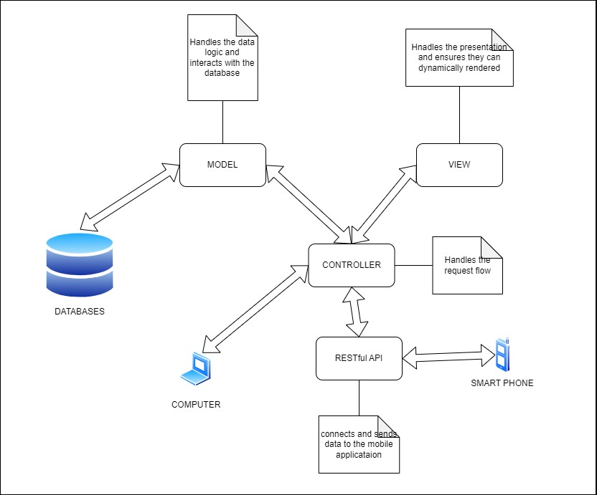
Figure 2 System Overview Diagram
Gives an overview of the system and how it interacts with other components for smooth operation

Logical Design

Use Case Diagrams

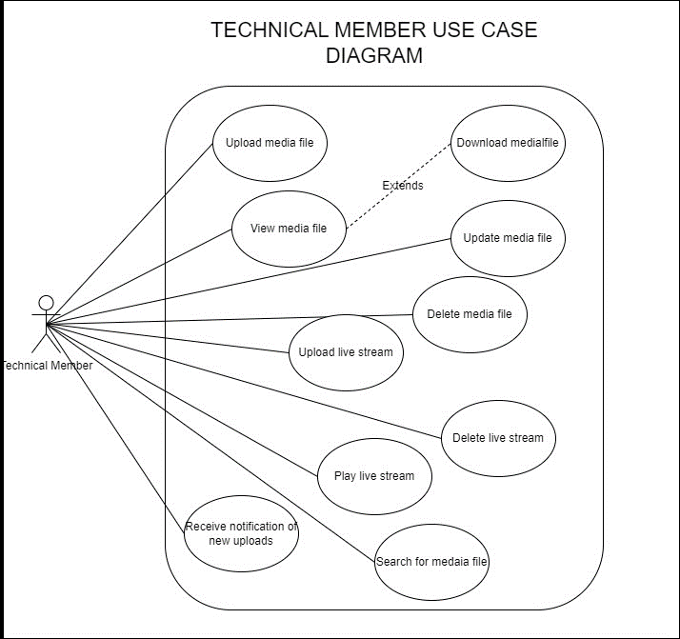
Figure 3. Technical Member Use Case Diagram

Activity Diagrams

Class Diagram
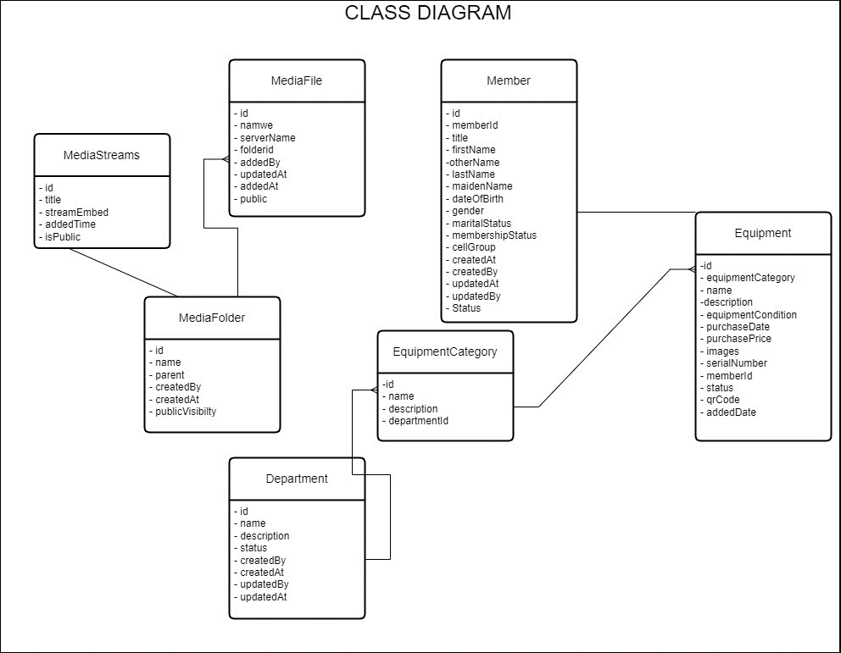
Figure 4. Class Diagram

Sequence Diagrams

Database Design

Security Design

System Implementation (Required Section for Computer Science Project)

System Development

System Deployment

Chapter Summary

RESULTS

Introduction
This chapter describes and analyses the information generated from the data that was obtained from the administration of the questionnaires. The results will be presented using determined and suitable data analysis instruments and in this regard the study has made use of descriptive statistics which is presented in frequency distribution tables showing absolute and relative values. Following the 138 questionnaires administered to participants, 88 were returned to the researcher. This gave a total percentage of 63% answered and 36% unanswered. Results are presented using tables, charts, graphs. The table below illustrates the rate of the questionnaire administered:

Baseline Study Results (Optional Section for Computer Science Project)

Descriptive Statistics
The main objective of our analysis is to provide or find out answers to the research questions as to whether there exists a significant link between communication and performance; if communication variables have a positive impact on organizational performance; what communication difficulties are faced by employees and how can organizations improve upon their communication in order to increase productive levels.

Hypothesis Testing (Inference Statistics) / Thematic Analysis
Correlation is used as a way to establish if there is a mutual relationship between two or more things especially when one causes or influences the other. In this study the researcher used Pearsons correlation.

System Automation and Implementation Results (Required Section for Computer Science Project – 20 pages or more. Include description for every diagram)

System Implementation Results

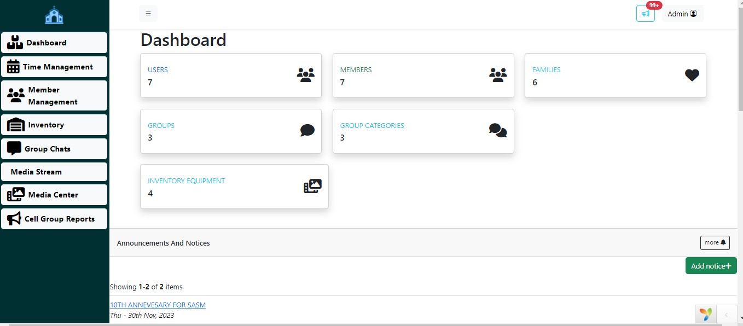
Figure 5. Dashboard

Media File and Media Folder Module
This module is a combination of two modules the accessed by the admin and the church members to access the media content of the church made available by the system admin. This module contains the video, audio, picture and the document. The media folder provides a provision to store the different media in the proper category to make the system more efficient and user friendly. While the media file is the actual media which will be made available to the church members by the admin and will be accessible.

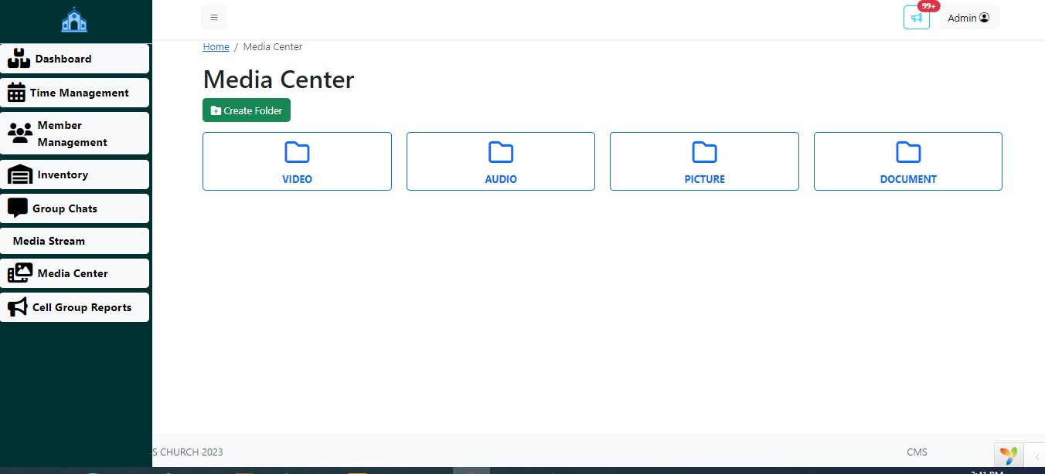
Figure 6. Media Center

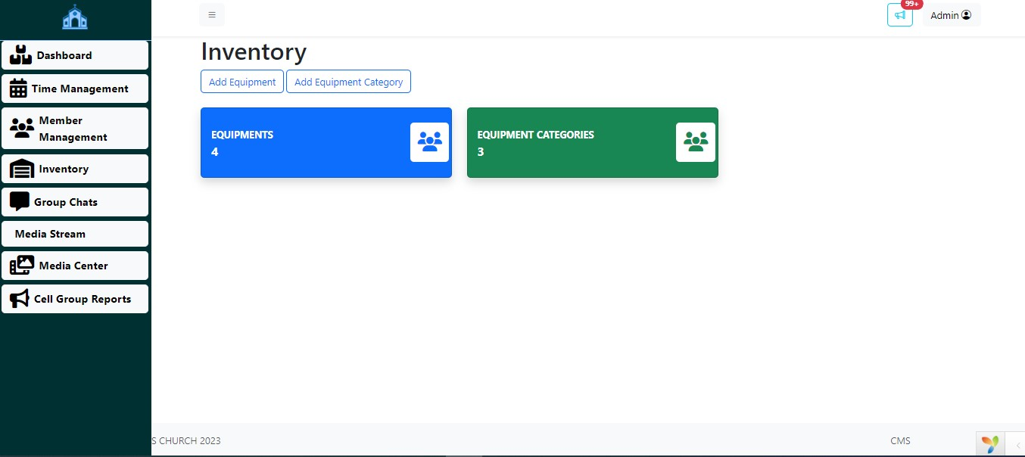
Figure 7. Inventory Dashboard

System Validation

The table shows significance of .041 at 5% level between communication channel variable; channel normally used and effective communication variable; receives information from preferred sources

Chapter Summary
This chapter presented the results of the descriptive analysis and explains why each analysis was undertaken. The chapter also presented the results of the correlation and regression analysis which utilized Pearson’s correlation coefficient. The results of the hypothesis testing were also presented.

DISCUSSION AND CONCLUSIONS

Introduction
This chapter presents answers to the study questions in the first chapter. The conclusions and answers to the study questions are founded on descriptive, regression and correlation analysis results. The chapter also recommends how effective communication can be enhanced to improve organisational performance.

Discussion
This section discusses the finding to answer the research questions developed in the first chapter.

Objective 1 Discussion
The first research question was developed to identify factors affective effective communication based on the systems theory. To answer the question, the researcher analysed questionnaire responses in form of descriptive statistics using SPSS. The figure below shows the results.

Objective 2 Discussion
The researcher developed three hypothesis and used pearsons correlation to identify if there is a significant relationship between the variables in the model used and to determine the strengths of these relationships. The level of significance was used for the correlation analyses, the P-value, was 0.05 and the Degrees of Freedom (df) = N – 1 (where N is the

Conclusions
The main purpose of the study was to devise a model of effective communication that enhances organisational performance. The study randomly selected 3 consultancy companies

Recommendations
Give your recommendations based on your findings

Future Works
Give details of the future works. Limitations of your study, what you have achieved and proposed future works

Chapter Summary
This chapter discussed and concluded the study. The chapter showed how the research questions were answered. The results to the hypothesis testing were also presented and a conclusion was drawn

REFERENCES
Use IEEE Format Reference Style
[1] "A Low-Cost IoT-Based Smart Weather Station for Real-Time Environmental Monitoring," in Proc. IEEE Conf., M'sila, Algeria, Dec. 2025.

[2] "Design and Implementation of Micro Meteorological Monitoring Station," in Proc. IEEE Conf., Xi'an, China, May 2025.

[3] World Meteorological Organization, "Functional Specifications for Automatic Weather Stations," in Proposal for Amendments of the Guide to Meteorological Instruments and Methods of Observation (WMO-No. 8), Geneva, 2004.

[4] "Development of an IoT-Based Real-Time Weather Station for Environmental Monitoring," in Proc. IEEE Conf., Bengalore, India, Jan. 2026.

[5] "Hybrid Cloud-Integrated and GAN-Based Deep Learning Framework for Prediction of Environmental Time Series," IEEE Access, Dec. 2025.

[6] "Design and Implementation of a Low-Cost Automatic Weather Station Based on the Internet of Things," in Proc. AIESRE, Tizi-Ouzou, Algeria, Dec. 2025.

[7] "Real Time Cloud-Based Weather Monitoring System using NodeMCU," in Proc. IEEE Conf., NOIDA, India, Dec. 2023.

[8] World Meteorological Organization, "Definition of Automatic Weather Station," in Guide to Meteorological Instruments and Methods of Observation, WMO-No. 8.
[9] "Solar-Powered Weather Monitoring System with Cloud Integration," in Proc. IEEE Conf., Miri Sarawak, Malaysia, Nov. 2025.

APPENDICES

Appendix 1 - Questionnaire

